A landlord creates one Property first. That Property can contain many Units. The Property and Units have separate photos and amenities, while the Property itself has its own verification documents. Nothing becomes publicly visible until the property is approved by the admin.

Example reference: Para dili na mag tagsa tagsa ug verify and ADMIN.

Katong feature sa pag pin sa location then makita ang adress automatic kay i retain rato.
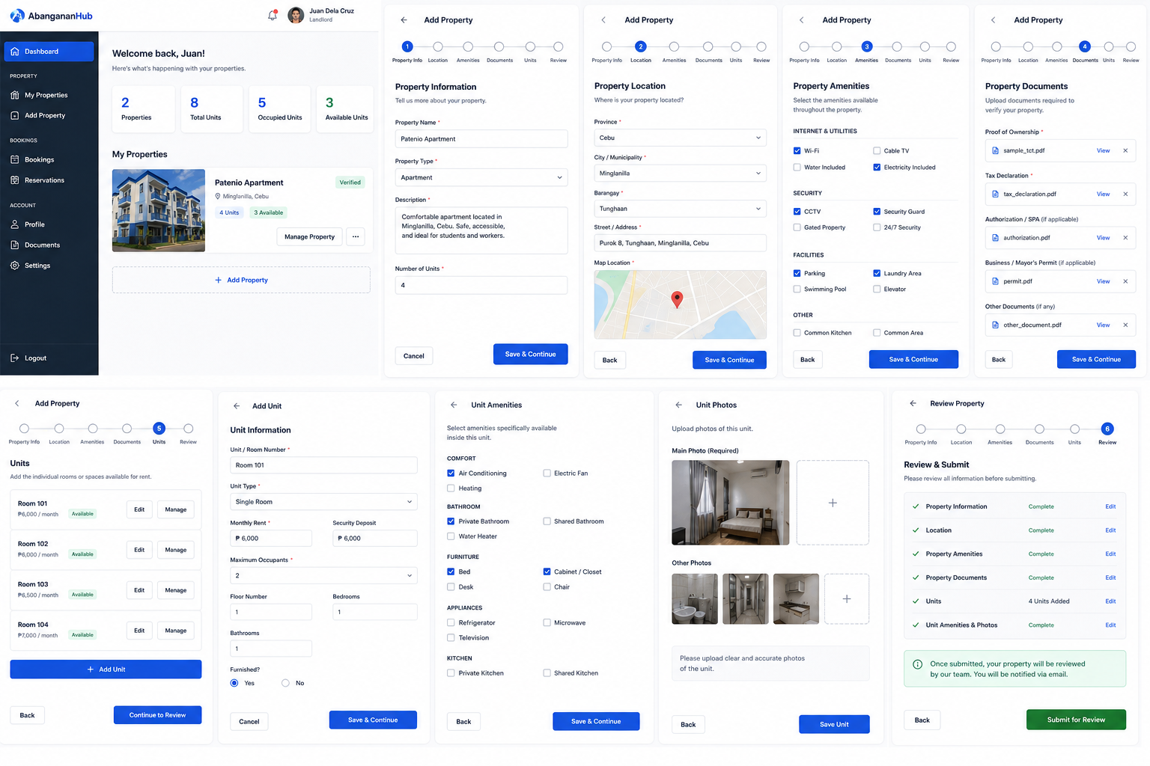

The system allows landlords to register, verify their identity and legitimacy, add rental properties, add individual rental units, upload property and unit photos, specify amenities, submit legal documents, and submit their property for administrator verification.
The main objective is to prevent fraudulent or misleading rental listings. Therefore, a landlord's property must not immediately become visible to renters after being created.
The property must go through an administrative review process first.
The basic process is:
Login → Become a Landlord → Landlord Verification → Landlord Approved → Add Property → Property Information → Property Location → Property Photos → Property Amenities → Property Documents → Add Units → Unit Information → Unit Photos → Unit Amenities → Review → Submit for Admin Review → Admin Verification → Approved → Published → Visible to Renters.

Add Property Stepper
The Add Property process should be divided into several steps instead of using one long form.
Recommended steps:
- Property Information
- Property Location
- Property Photos
- Property Amenities
- Property Documents
- Units
- Review and Submit
The landlord should be able to move between completed steps.
The landlord should also be able to save the property as a draft.
For example, if the landlord completes Property Information and Location but closes the browser, the property should remain saved as a Draft.
When the landlord returns to the dashboard, the system should show:
Patenio Apartment
Status: Draft
Button: Continue Setup

STEP 1 Property Information
The first step collects the general information about the property.
The form should contain:
Property Name
Property Type
Property Description
Property Name is required.
Example:
Patenio Apartment
Property Type should be selected from predefined choices.
Suggested property types include:
Apartment
Boarding House
Dormitory
Condominium
House
Bedspace
Other
The landlord must also provide a description.

STEP 2 Property Location
The next step collects the property's location.
Pwede rato same sa atoa pag kuhas location nga pag pin , kay automatic makuha ang details
Because AbangananHub is intended only for Cebu, the system should restrict property locations to Cebu.
The form should contain:
Province
City/Municipality
Barangay
Street/Address
Latitude
Longitude
The province should be Cebu.
The system should also allow the landlord to select the property's location on a map.
The map should save latitude and longitude.
This can later be used by renters to view the property's location.
The system should validate that the selected property location is within the allowed Cebu coverage area.

STEP 3 Property Photos
The property must have photos.
Property photos represent the entire property or establishment, not an individual rental unit.
The landlord should upload at least one main property photo.
Additional photos can also be uploaded.

Step 4 – Property Amenities
The next step allows the landlord to identify amenities available throughout the property.
Examples:
Wi-Fi
CCTV
Parking
Laundry Area
Common Kitchen
Common Area
Security Guard
Gated Property
Swimming Pool
Elevator
Garden
Cable TV
Water Included
Electricity Included
The amenities should be organized into categories.
For example:
Internet and Utilities:
Wi-Fi
Cable TV
Water Included
Electricity Included
Security:
CCTV
Security Guard
Gated Property
24/7 Security
Facilities:
Parking
Laundry Area
Common Kitchen
Common Area
Swimming Pool
Elevator
Garden
The landlord can select amenities using checkboxes or selectable cards.

10. Amenities Database
Instead of creating a new amenity record every time a landlord selects one, use a central amenities table.
Create:
amenities
Fields:
id
name
category
description
icon
status
created_at
updated_at
Example records:
1 – Wi-Fi – Internet
2 – CCTV – Security
3 – Parking – Facilities
4 – Laundry Area – Facilities
5 – Security Guard – Security
6 – Swimming Pool – Facilities
Then create a junction table:
property_amenities
Fields:
id
property_id
amenity_id
created_at
This creates a many-to-many relationship.
One property can have many amenities.
One amenity can belong to many properties.
Example:
Property 100 has:
Wi-Fi
CCTV
Parking
The property_amenities table would contain:
property_id 100 – amenity_id 1
property_id 100 – amenity_id 2
property_id 100 – amenity_id 3
A unique constraint should be placed on:
property_id + amenity_id
This prevents duplicate amenities.

Step 5 – Property Documents
This is the property verification section.
The purpose is to allow the administrator to verify that the property is legitimate and that the landlord has the authority to offer the property for rent.
The documents should not be publicly displayed.
Only authorized administrators should have access to these documents.
Possible documents include:
Proof of Ownership
Tax Declaration
Authorization or Special Power of Attorney, when applicable
Business/Mayor's Permit, when applicable
Occupancy or building-related documents, when applicable
Fire safety-related documents, when applicable
Other supporting documents
The system should not blindly require every document from every landlord.
The required documents can depend on the type of landlord, property, and applicable legal requirements.
The administrator should be able to request additional documents when necessary.

12. Property Documents Database
Create:
property_documents
Fields:
id
property_id
document_type
file_path
file_name
document_number
status
rejection_reason
verified_by
verified_at
expiry_date
created_at
updated_at
Document status can be:
Pending
Verified
Rejected
Expired
The administrator can open the document and verify it.
If rejected, the administrator must be able to provide a reason.
Example:
"Uploaded document is unclear. Please upload a clearer copy."
The landlord can then replace the document and resubmit.

Step 6 – Add Units
After the property information has been completed, the landlord creates the individual rental units.
Example:
Patenio Apartment
Room 101
Room 102
Room 103
Room 104
There should be an:
"+ Add Unit"
button.
Each unit is created separately.

14. Unit Information
The unit form should contain:
Unit/Room Number
Unit Type
Description
Monthly Rent
Security Deposit
Maximum Occupants
Floor Number
Bedrooms
Bathrooms
Furnished/Unfurnished
Availability Status
Example:
Unit Number: Room 101
Unit Type: Single Room
Monthly Rent: ₱6,000
Security Deposit: ₱6,000
Maximum Occupants: 2
Floor: 1
Bedrooms: 1
Bathrooms: 1
Furnished: Yes
Availability: Available
The system should allow the landlord to create multiple units under the same property.

15. Unit Types
Suggested unit types:
Single Room
Bedspace
Studio
1 Bedroom
2 Bedroom
3 Bedroom
House
Condominium Unit
Other
The exact choices can be adjusted according to the project's requirements.

16. Unit Availability
Each unit should have an availability status.
Recommended values:
Available
Reserved
Occupied
Maintenance
Unavailable
The status should be controlled carefully.
For example, if a unit has an active rental agreement, the system should not allow the landlord to incorrectly mark it as Available.

17. Units Database
Create:
units
Fields:
id
property_id
unit_number
unit_type
description
monthly_rent
security_deposit
maximum_occupants
floor_number
bedrooms
bathrooms
furnished
availability_status
created_at
updated_at
The property_id connects the unit to its parent property.
Relationship:
Property → Units
One-to-many.
Example:
Property ID 100:
Unit 101
Unit 102
Unit 103
Unit 104

18. Unit Photos
Each unit should have separate photos.
This is extremely important.
Property photos show the entire establishment.
Unit photos show the exact space that the renter will rent.
For example:
Property photo:
Photo of Patenio Apartment's exterior.
Unit photo:
Photo of Room 101's bedroom.
The landlord should upload:
Main Unit Photo
Additional Unit Photos
Recommended photos include:
Bedroom
Bathroom
Kitchen, if applicable
Living area
Closet
Balcony, if applicable
The system should allow the landlord to:
Upload
Delete
Reorder
Set primary photo
At least one unit photo should be required before submitting the property.

19. Unit Photos Database
Create:
unit_photos
Fields:
id
unit_id
file_path
file_name
is_primary
display_order
status
created_at
updated_at
Relationship:
Unit → Unit Photos
One-to-many.

20. Unit Amenities
Unit amenities are different from property amenities.
Property amenities are shared or available throughout the property.
Unit amenities describe what is available specifically inside the unit.
Examples:
Air Conditioning
Electric Fan
Private Bathroom
Shared Bathroom
Water Heater
Bed
Cabinet
Desk
Chair
Refrigerator
Microwave
Television
Private Kitchen
Shared Kitchen
For example:
Property:
Wi-Fi
CCTV
Parking
Laundry
Room 101:
Air Conditioning
Private Bathroom
Bed
Cabinet
Room 102:
Electric Fan
Shared Bathroom
Bed
Cabinet

21. Unit Amenities Database
Create:
unit_amenities
Fields:
id
unit_id
amenity_id
created_at
This uses the same central amenities table.
Relationship:
Units → Unit Amenities → Amenities.
A unique constraint should be placed on:
unit_id + amenity_id
to prevent duplicates.

22. Complete Add Property Review
Before the landlord submits the property, the system should display a Review page.
The Review page should show:
Property Information
Property Location
Property Photos
Property Amenities
Property Documents
Units
Unit Information
Unit Photos
Unit Amenities
Each section should have an Edit button.
Example:
Property Information:
Patenio Apartment
Apartment
Description...
Edit
Location:
Minglanilla, Cebu
Barangay Tunghaan
Address...
Edit
Property Photos:
Photo 1
Photo 2
Photo 3
Edit
Property Amenities:
Wi-Fi
CCTV
Parking
Laundry
Edit
Documents:
Proof of Ownership – Uploaded
Tax Declaration – Uploaded
Permit – Uploaded
Edit
Units:
Room 101 – ₱6,000/month
Room 102 – ₱6,000/month
Room 103 – ₱6,500/month
Room 104 – ₱7,000/month
Edit
The landlord should confirm:
"I confirm that the information and documents submitted are accurate and complete."
Then:
"Submit for Admin Review"

23. Submission Process
When the landlord clicks Submit for Admin Review, the system should first validate the property.
The system should check:
Property name exists.
Property type exists.
Description exists.
Location exists.
Property is within Cebu.
At least one property photo exists.
A primary property photo exists.
Required property amenities information is complete.
Required documents are uploaded.
At least one unit exists.
Each unit has a unit number.
Each unit has a rental price.
Each unit has a maximum occupancy.
Each unit has at least one photo.
Each unit has its required information.
If something is missing, the system should not submit the property.
Instead, it should show exactly what is missing.
Example:
"Your property cannot be submitted yet."
Missing:
Property main photo.
Proof of ownership.
Room 102 main photo.
Room 103 monthly rent.

24. Property Status
The property should have a verification status.
Recommended values:
Pending
Under Review
Approved
Rejected
The property should also have a publication status.
Recommended values:
Draft
Unpublished
Published
Suspended
Archived
Keeping verification and publication separate is recommended.
For example:
Verification status: Approved
Publication status: Suspended
This means the property was previously verified but is currently not publicly available.

25. Property Workflow
The complete property status flow is:
Draft → Submitted → Under Review → Approved → Published.
If rejected:
Under Review → Rejected → Landlord Corrects Information → Resubmits → Under Review.
If the administrator approves:
Under Review → Approved → Published.
The administrator should be able to publish the listing only after the verification requirements have been satisfied.

26. Public Listing Rule
This is one of the most important requirements of AbangananHub.
A property must NOT be visible to renters while it is:
Draft.
Submitted.
Under Review.
Rejected.
Only properties that are approved and published should appear in public property searches.
The public listing query should effectively require:
verification_status = approved
AND
publication_status = published.
Therefore:
Draft property = Not visible.
Pending property = Not visible.
Under Review property = Not visible.
Rejected property = Not visible.
Approved and Published property = Visible.
Suspended property = Not visible.
Archived property = Not visible.

27. Admin Property Review
The administrator should have a Property Verification page.
The administrator should see:
Property information.
Landlord information.
Property location.
Property photos.
Property amenities.
Property documents.
Units.
Unit photos.
Unit amenities.
The administrator should be able to verify the information.
The admin interface should provide:
View Document
Approve Document
Reject Document
Request Additional Document
Approve Property
Reject Property
Suspend Property
If the administrator rejects the property, a rejection reason should be required.
Example:
"Property ownership document is unclear."
"Unit photos do not sufficiently represent the listed unit."
"Required information is incomplete."

28. Admin Verification Does Not Mean Documents Are Public
The property verification documents should remain private.
Renters should not see:
TCT or ownership documents.
Tax declarations.
Business permits.
IDs.
Authorization documents.
Other confidential documents.
Instead, renters only see that the listing has been verified.
For example:
"Patenio Apartment – Verified"
The actual documents remain accessible only to authorized administrators.

29. Property Database
The main properties table should contain:
id
landlord_id
property_name
property_type
description
province
city_municipality
barangay
street_address
latitude
longitude
verification_status
publication_status
rejection_reason
reviewed_by
reviewed_at
created_at
updated_at
The landlord_id is a foreign key to the user/landlord account.

30. Unit Database
The units table should contain:
id
property_id
unit_number
unit_type
description
monthly_rent
security_deposit
maximum_occupants
floor_number
bedrooms
bathrooms
furnished
availability_status
created_at
updated_at
The property_id is a foreign key to properties.

31. Property Photos Database
property_photos:
id
property_id
file_path
file_name
is_primary
display_order
status
created_at
updated_at
Relationship:
Properties 1 → Many Property Photos.

32. Unit Photos Database
unit_photos:
id
unit_id
file_path
file_name
is_primary
display_order
status
created_at
updated_at
Relationship:
Units 1 → Many Unit Photos.

33. Amenities Database
amenities:
id
name
category
description
icon
status
created_at
updated_at
This table stores the master list of amenities.

34. Property Amenities Database
property_amenities:
id
property_id
amenity_id
created_at
Relationship:
Properties Many ↔ Many Amenities.

35. Unit Amenities Database
unit_amenities:
id
unit_id
amenity_id
created_at
Relationship:
Units Many ↔ Many Amenities.

36. Property Documents Database
property_documents:
id
property_id
document_type
file_path
file_name
document_number
status
rejection_reason
verified_by
verified_at
expiry_date
created_at
updated_at
This table is for property verification documents.

37. Complete ERD Relationship
The basic ERD relationship should be:
Users → Properties → Units.
Properties also connect to:
Property Photos
Property Documents
Property Amenities.
Units connect to:
Unit Photos
Unit Amenities.
Amenities are shared between properties and units.
Conceptually:
Users have many Properties.
Properties belong to one User/Landlord.
Properties have many Units.
Units belong to one Property.
Properties have many Property Photos.
Property Photos belong to one Property.
Properties have many Property Documents.
Property Documents belong to one Property.
Properties have many Amenities through Property Amenities.
Units have many Amenities through Unit Amenities.
Units have many Unit Photos.
Unit Photos belong to one Unit.

38. Complete Database Structure
The Add Property module should therefore contain these tables:
users
properties
property_photos
property_documents
amenities
property_amenities
units
unit_photos
unit_amenities
For the later rental functionality, additional tables can be connected to units:
reservations
reservation_payments
rentals
rental_payments
tenants
leases
But these should be treated as a separate stage from the Add Property module.

